Assignment 2

# Objective

You will use the Excel ToolPak to compute descriptive statistics.

# Preparation

Read the [information about Excel](https://moodle.clarku.edu/mod/page/view.php?id=550728) posted on the course homepage and load the Excel ToolPak onto your computer. Clark Students have access to download and use Microsoft Excel. If you have trouble loading the ToolPak, please contact the [ITS Help Desk](https://www.clarku.edu/offices/its/get-it-help/#:~:text=The%20ITS%20Help%20Desk%20offers%20the%20Clark%20community,ITS%20%E2%80%9Cticket%E2%80%9D%20will%20be%20submitted%20to%20the%20specialist.).

Experience with Microsoft Excel, specifically the Excel Analysis Toolpak (previously known as ‘StatsPack’) is an important skill for this class.

Please understand that this course does not require you to be proficient in Excel. This is merely a suggestion for you as an aspiring professional evaluator.

I’ve found several helpful videos and other references to help you become familiar with this data analysis program. Know that there are other programs that researchers and evaluators use such as, but not limited to, the Statistical Package for the Social Sciences ([SPSS](https://www.ibm.com/products/spss-statistics)) developed by IBM, and [R](https://www.r-project.org/), a programming language and free software for statistical computing supported by the R Foundation for Statistical Computing. If you’re planning a career in evaluation, you’ll want to be familiar with programs such as these.

# Assignment

Compute descriptive statistics in Excel with the Data Analysis ToolPak. Watch this helpful [video](https://www.youtube.com/watch?v=h-RzBhBzJOQ) and then practice with the dataset below.

|  |
| --- |
| **September Donations** |
| 2000 |
| 450 |
| 50 |
| 1500 |
| 250 |
| 500 |
| 2500 |
| 150 |
| 100 |
| 350 |
| 500 |
| 100 |
| 5000 |
| 550 |

1. Find the following descriptive statistics for the September donation data.

|  |  |
| --- | --- |
| **Descriptive Statistic** | **ToolPak Value** |
| Mean |  |
| Median |  |
| Mode |  |
| Standard Deviation |  |
| Variance |  |

Having trouble finding the ToolPak on your computer? Select “Alt” type “t” and then type “i” and select the Analysis ToolPak. Still don’t see it? Select the “Data” dropdown menu (pictured below) to see the Data Analysis option (on the top right).

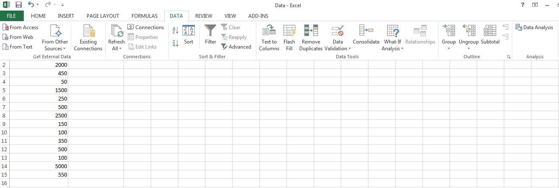

After following the steps in the video and obtaining the descriptive statistics, you should have stats for a total of 14 data points (or “counts”). If your count is 13 then you might have only selected the data and not the column label *with* the data and checked “Labels in first row.” To fix this, either uncheck the box next to “Labels in first row” or reselect the data with the column label.